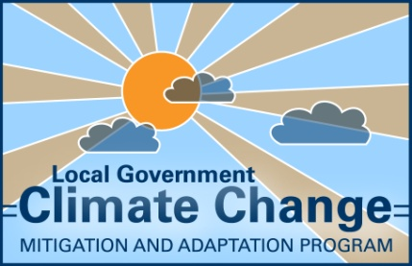
Module 3 –
Assessing Climate Change Risk

- Expected outcomes of this module
Climate change risk management is an emerging and interdisciplinary process. This module provides a methodology and suite of materials to assist facilitators and workshop participants to assess Council risks associated with climate change.
The expected outcomes of this module are that participants will:
- Identify potential risks to Council service areas as a result of climate change
- Analyse risk statements to determine preliminary level of risk
- Evaluate risks to develop a list of priority risk statements
- Resources required for module delivery
Delivery sequence | Complete following module 2 “Setting the Context”. The outcomes of this module are required for successful delivery of module 4 “Identifying and Prioritising Adaptation Actions”
Timeframe | - At least 3 hours for identifying risks  - At least 3 hours for analysing and prioritising risks
Participants | All members of the Climate Change Action Planning Team including:  - the Steering Committee  - the Working Group
Materials | - A computer (ideally with internet access)  - Projector and screen  - Whiteboard (optional)  - Whiteboard markers (optional)  - Module 3 PowerPoint presentation template  - Workshop Briefing Paper template  - Risk Assessment Tool  - Council risk assessment framework or risk assessment framework recommended by AGO (2006)  - Large sheets of paper (e.g. A1 size paper)  - Adhesive or thumb tacks to display paper  - Marker pens  - Evaluation forms (template available)
Assistance | An assistant is required to type up risk statements identified in the workshop

- How to complete the module
The following tasks should ensure that the expected outcomes of the module are achieved:
- Prepare and understand the risk evaluation framework including success criteria (essentially a summary of the organisation’s long term objectives), likelihood and consequence scales
- Understand risk statements and develop examples
- Present risk evaluation framework (success criteria, likelihood and consequence)
- Facilitate workshop participants to brainstorm climate change impact risk statements
- Facilitate analysis of each risk statement
- Undertake risk evaluation to finalise a prioritised list of risk statements
The information contained within this module was developed using Climate Change Impacts and Risk Management – A Guide for Business and Government developed by the (then) Australian Greenhouse Office
(AGO) in 2006. The “AGO 2006 guidelines” should be used throughout the delivery of this module. The guidelines are available on the LGSA website www.lgsa.org.au. The AGO 2006 guidelines note that identifying, analysing and evaluating the risks is best undertaken as a single exercise. However, this may be too much to cover in one workshop and more than one workshop may be required. This module may be completed as one full day workshop or two half day workshops, the first for identifying risks and the second for analysing and prioritising risks. However, it is possible several workshops may be needed.
The workshop/s for this module are likely to be most effective if led by an experienced facilitator or possibly an independent risk assessment specialist. It is recommended that an additional person assist to record outputs from the brainstorming of risk statements. Attention should be paid to ensuring consensus on outputs and this can be facilitated by projecting risk statements onto a screen or a similar means of making the proceedings visible to participants (e.g. recording information on a whiteboard). It is also important to build the understanding and support for this process and its outcomes from senior staff and councillors as they are likely to be responsible for decisions regarding acting on and communicating the risks.
  - Module preparation

3.1.1 Establishing the scenario, scope and stakeholders
Establishing the context for risk management is important as it sets a foundation so that everyone can work from a common understanding of the scope of the exercise and how it will be undertaken. It also means the risk management process can be repeatable and clearly communicated.
The facilitator, together with the Steering Committee, should:
- Select one or two climate change scenarios to work from (see module 2)
- Define the scope of the risk assessment including the operational activities to be covered by the risk assessment (i.e. everything Council does or a specific subset of its activities), geographic boundaries and the time horizon. It is recommended that the entire scope of Council’s operations be addressed in one assessment exercise if possible
- Determine which stakeholders need to be consulted to take their views into account, which stakeholders should be involved in the analysis and who should be informed of the outcomes of the risk assessment and action planning process
- Prepare a summary of this information on the climate change scenario/s, scope and stakeholders for inclusion in the Workshop Briefing Paper and module 3 PowerPoint presentation

3.1.2 Preparing a risk evaluation framework
The objective of this task is to prepare an appropriate risk evaluation framework that is relevant to Council service objectives. A robust framework will require three key components. These include:
- Appropriate scales to describe the level of consequence of a risk if it should happen
- Appropriate scales to describe risk likelihood of suffering that level of consequence
- A means of assigning a priority rating to a given consequence and likelihood.
Council may have an existing risk management framework which is used for managing financial or Occupational Health and Safety risks. The Steering Committee should determine whether current risk management frameworks are appropriate for use in assessing climate impact risk (see case study on Townsville City Council). Using an existing risk management framework enables the output of the climate change risk analysis to be comparable with other risk assessments Council has undertaken.
If Council does not have an existing framework, then the one outlined in the AGO 2006 guidelines is recommended. The AGO 2006 guidelines provide a generic framework for understanding climate change impacts and undertaking an initial risk assessment for Local Council. The purpose of the guidelines is to provide a starting point for local businesses and government. The risk matrix, consequence and likelihood scales for these guidelines are presented in Appendix A.
The facilitator should:
- Work with the Steering Committee to choose a risk evaluation framework
- Familiarise themselves with the chosen risk evaluation framework (Council’s existing framework or the one recommended in the AGO 2006 guidelines)
Case Study – Application of an existing Council risk framework to climate change impacts in Townsville City Council
Townsville City Council (TCC) has been very proactive in developing an Enterprise wide Risk Management Framework as part of its governance responsibilities. This framework is applied for all organisational risks including risks associated with climate variability. The Townsville region is prone to cyclones, flooding and wind related damage. The framework was adopted to provide a consistent, comprehensive approach to identifying and managing risk. The framework helps in addressing insurable risks, change management, service delivery, legislative and regulatory compliance. The Council framework includes success criteria with consequence and likelihood scales which had been customised according to its own corporate objectives. The success criteria are as follows:
- Financial – dollar cost
- People – human impact
- Reputation – damage to reputation and image
- Property/asset management – damage to property and assets
- Environmental – harm to the environment
- Strategy – strategy, or loss of opportunity
- Service delivery to customer – service delivery and meeting of customer expectations
TCC applied the risk management framework during its climate change adaptation planning. Using Council’s risk management framework had a number of advantages. Firstly, staff members were familiar with the process and therefore understood the risk identification and assessment tasks. Specific success criteria, likelihood and consequence scales also made risk assessment more relevant to staff objectives. This resulted in better interaction within the workshop and more meaningful results than if a generic framework had been used. Townsville City Council won the 2009 Local Government Risk Management Excellence Award at the Local Government Association of Queensland Conference in recognition of its contemporary and comprehensive risk management framework.

3.1.3 Understanding risk statements
The objective of this task is to practice developing risk statements before the workshop. Developing risk statements can often be confusing and it is important to understand the process before facilitating a workshop in this subject.
The facilitator should:
- Familiarise themselves with the information in Box 1 - Developing detailed risk statements
- Develop a number of example risk statements and test them using the risk evaluation framework
- Prepare some examples of risk statements to discuss in the workshop

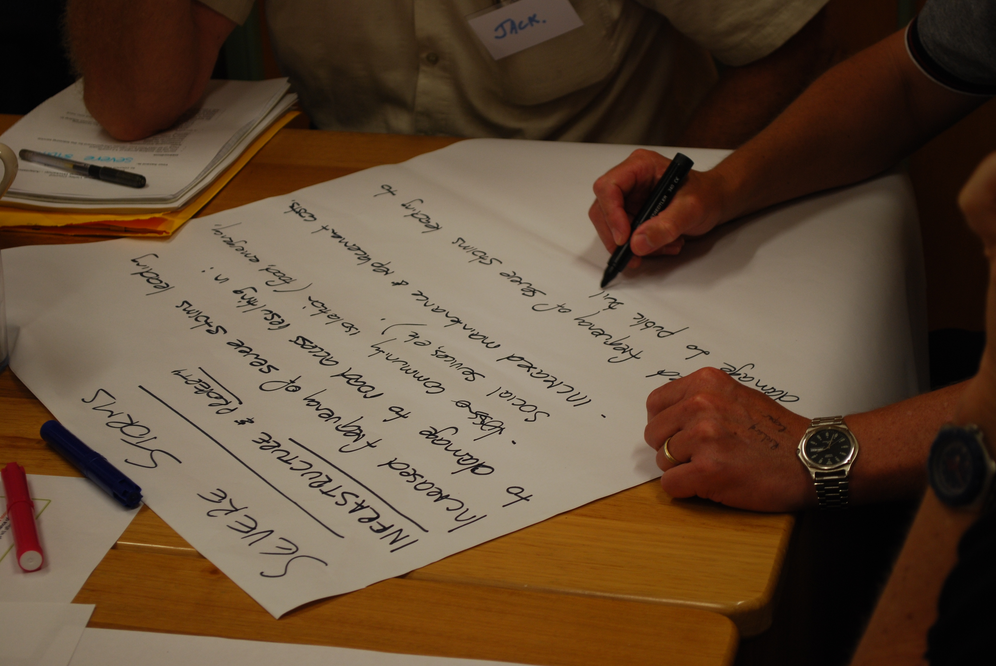

Above: Developing risk statements during preliminary brainstorming of potential risks by Clarence Valley Council (November, 2009)

Box 1 – Developing detailed risk statements
Facilitating the development of detailed risk statements is essential during the risk identification task. Risk statements should be detailed enough so they can be analysed using the likelihood and consequence scales. The following recommendations are provided for developing detailed risk statements:
- Try and include the climate impact (source), the hazard associated with that impact (event) and the consequence of that hazard to Council objectives.
- Test the risk statement to see if it can be assessed using the likelihood and consequence scales.
Below are examples of an adequate risk statement and one which may not be detailed enough for assessment:
Hazard associated with the impact
It is not clear how increased maintenance of buildings will affect Council objectives
Consequence of hazard to Council objectives (financial)
Climate impact
Example of an adequate risk statement

Increased frequency of hot days, leading to accelerated deterioration of Council assets resulting in increased maintenance costs to Council

Example of a risk statement which may not be detailed enough

Increased hot days leading to increased maintenance of buildings

A number of hazards may be associated with a single climate impact and a number of consequences may arise from the one hazard (see the “risk tree” in Appendix B). In such cases, separate risk statements should be developed for all consequence as outlined below:
Consolidated risk statement:
Increased frequency of hot days, leading to accelerated deterioration of Council assets resulting in increased maintenance costs to Council and increased liability to Council due to decreased public safety.
Separated risk statement
- Increased frequency of hot days, leading to accelerated deterioration of Council assets resulting in increased maintenance costs to Council
- Increased frequency of hot days, leading to accelerated deterioration of Council assets resulting in increased liability to Council due to decreased public safety.

Separating risk statements will increase the ease of analysis and improve the quality of the adaptation actions.

3.1.4 Narrowing in on key elements
In order to identify risks in a systematic and efficient manner it can help to break the issues facing your council into discrete elements. Key elements are a set of topics that can be considered one by one, enabling more focus and more in depth consideration for each topic than trying to address everything at once. The use of key elements can ensure that all important issues are raised and effort is balanced between the topics. The set of key elements must be comprehensive, covering all significant issues, leave scope for creative input and achieve an appropriate level of detail. An example of key elements is listed in the AGO 2006 guidelines (page 42):
- Service delivery
- Related services and service providers
- Personnel
- General public
- Systems and equipment
- Administration and support
The facilitator should:
- Consider using this or another list of key elements. If key elements are used, the facilitator should explain thoroughly what the key elements cover. When assigning key elements to groups of workshop participants, the facilitator should ensure that there is at least one person in each group that has expertise in that area.

3.1.5 Preparing workshop materials
This task involves preparing materials for the workshop, which include:
- The module 3 PowerPoint presentation (template available from the LGSA)
- The Workshop Briefing Paper (template available from the LGSA)
- A handout with information for the brainstorming activity (template available from the LGSA)
- The Risk Assessment Tool (available from the LGSA)
The facilitator should:
- 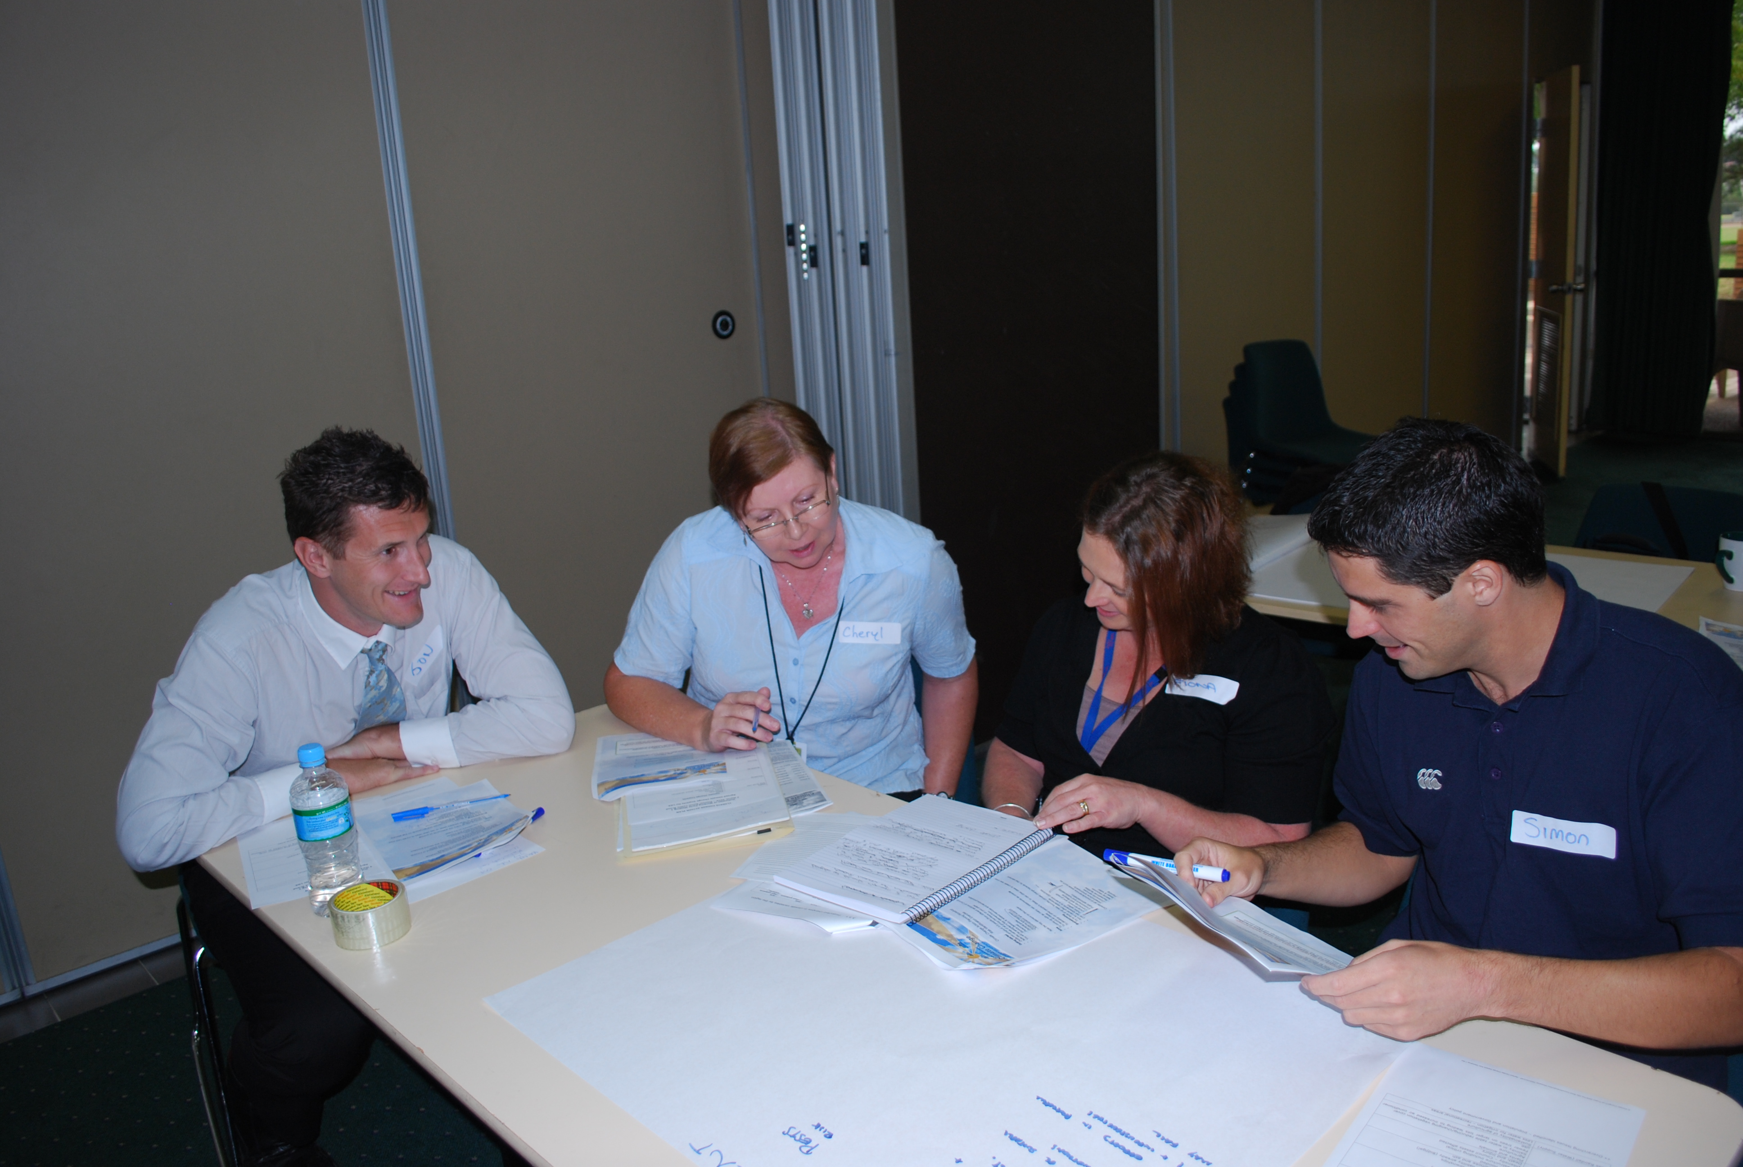Finalise the module 3 PowerPoint presentation by including relevant information such as the climate change scenario/s, the scope of the risk assessment, the chosen key elements and risk evaluation framework
- Finalise the Workshop Briefing Paper together with the Steering Committee and distribute to the Working Group prior to the workshop
- Print the handout for the risk identification activity
- Become familiar with the PowerPoint presentation, Workshop Briefing Paper and handout for the risk identification activity
- Assemble the necessary materials (listed on page 1)
Above: Workshop participants using a Workshop Briefing Paper and handout at The Hills Shire Council’s first risk assessment workshop (April, 2010)

  - Workshop facilitation

3.2.1 Presenting risk evaluation framework
This task involves presenting the risk evaluation framework to the Working Group.
The facilitator should:
- Present the introductory information on risk assessment, the risk assessment framework and the development of adequate risk statements (from the module 3 PowerPoint presentation)

3.2.2 Brainstorming risk statements
This task involves facilitating the working group to brainstorm climate change impact risk statements.
The facilitator should:
- Provide guidance in the development of detailed risk statements (from the module 3 PowerPoint presentation)
- Divide the Working Group into smaller breakout groups of 3 or 4 people and provide them with large sheets of paper (e.g. A1 size) and marker pens
- Assign each group a key element (as in section 3.1.4 on page 5) or a climate change impact for which to develop climate change risk statements
- Adopt the conventional rules of brainstorming that allow almost any input and suspend judgement. For example, “Increase in sea surface temperature leading to increased public use of beaches resulting in increased incidence of shark attacks” may sound like a far fetched risk but could be legitimate for a particular Council service area and should not be dismissed at this stage of the assessment
- Encourage participants to work systematically through each key element and each climate scenario (if more two are used) (rather than randomly developing risk statements). Or if preferred, work through each climate impact. Developing Risk Trees (see Appendix B) can assist this process
- Prevent the workshop from being diverted into debating whether a risk is a climate change risk or not. If in doubt let the risk remain in the process and consider the matter after the workshop with the Steering Committee
- Ensure that risk statements are associated with a service area/ success criteria
- Encourage participants to think about the implications of projected climate change on social and economic issues within the LGA. Economic issues could include changes to agricultural productivity in a rural council due to decreased water availability. An example of a social issue could include the increased requirement for community transport services to community facilities (such as air conditioned facilities and medical centres) by elderly populations due to increased heat waves
- Examine the risk statements to make sure that they are detailed enough to analyse and evaluate in terms of success criteria, likelihood and consequence. Risk statements should NOT be discarded, but should be adapted in consultation with the relevant Council service area to an appropriate level of detail (See Box 1)

3.2.3 Analysing each risk statement
This task involves facilitating the working group to analyse risk statements identified in the previous task to determine a level of risk for each statement.
The facilitator should:
- Present and explain the chosen risk evaluation framework to participants (using the module 3 PowerPoint presentation) and pay particular attention to:
- Success criteria and how they relate to Council objectives
- Consequence and likelihood scales
- Risk analysis matrix
(Examples can be found in Tables 1- 3 at Appendix A)
- Explain the risk analysis process. It is important that Council’s current controls are considered when determining the likelihood and consequence of each risk statement (risk analysis). Only measures that are already in place or committed and require no further action for implementation can be considered as controls. Examples of controls can be found in Table 4 of Appendix A
- Facilitate the working group to rate the likelihood and consequence of each risk statement and calculate a risk level according to the risk analysis matrix. It is important to ensure that the entire risk statement is being analysed rather than the hazard or the climate impact. Risk analysis can be completed using the Risk Assessment Tool (See Box 2)
Box 2 – Using the risk assessment tool
This information in Box 2 relates to the risk assessment tool supplied with these guidelines.
- Input all risk statements and associated climate variables, success criteria, service area and current control measures (if any) into the tool.
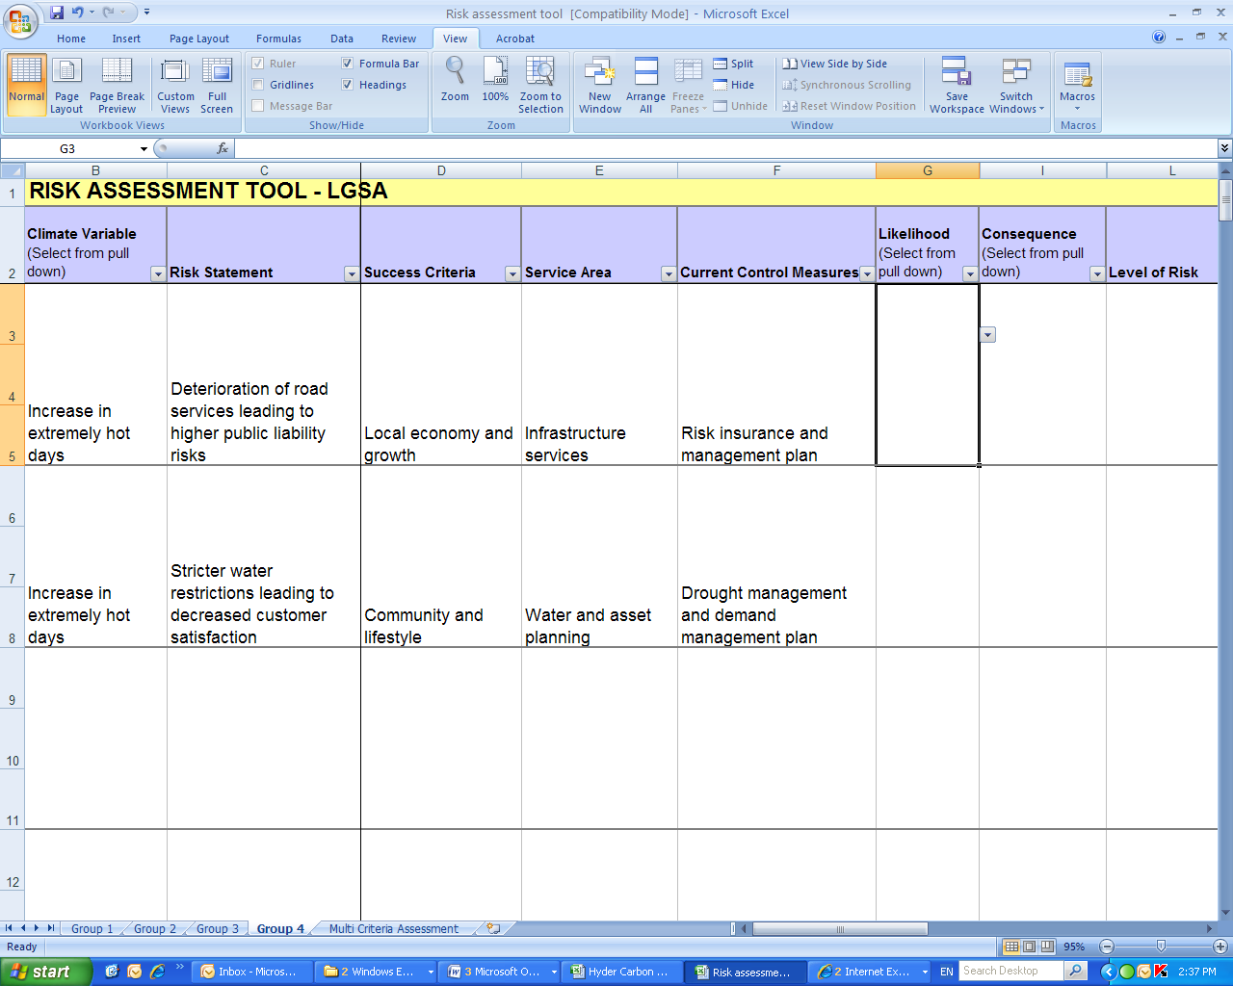
- Assess the risk statement using the risk evaluation framework (likelihood, consequence and success criteria – see Appendix B). Use the drop down menus to input these into the tool.
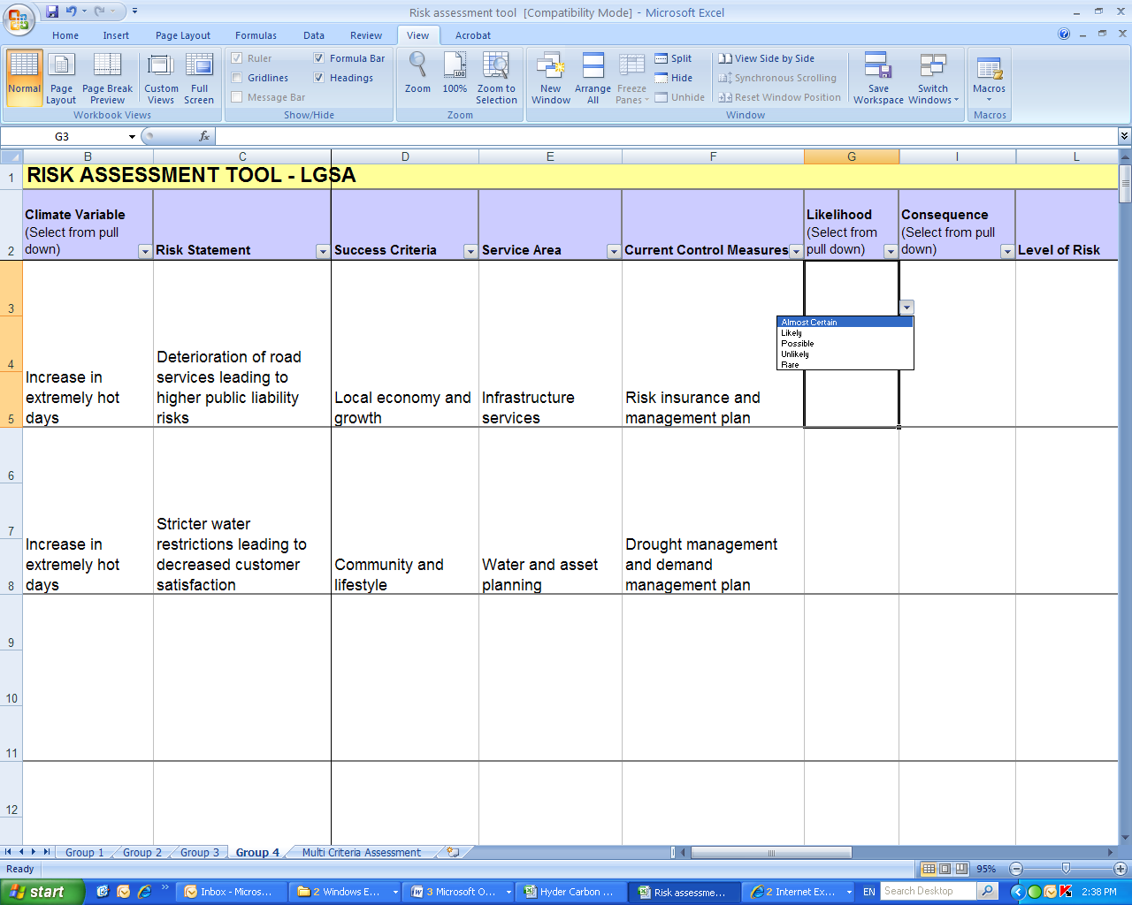
- After rating likelihood and consequence, the tool will calculate the level of risk.
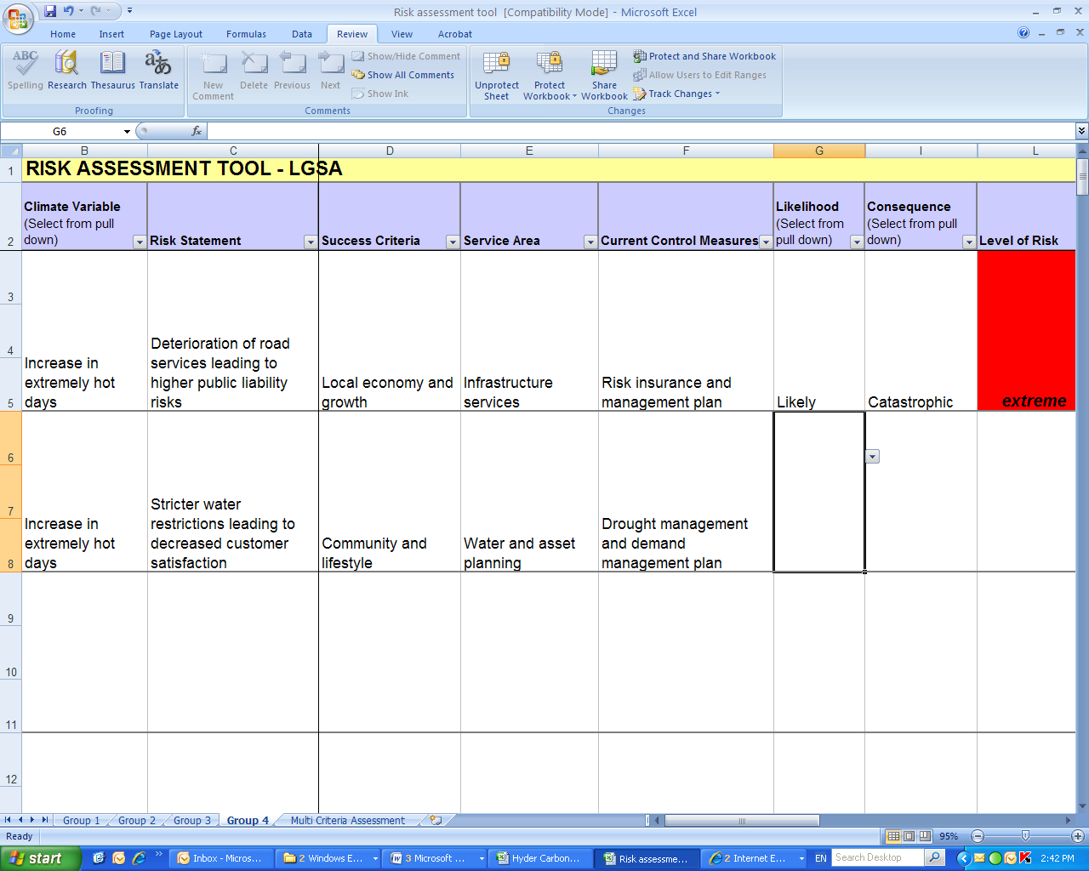
- The worksheets may be locked to prevent people from accidentally erasing formulas. They can be unlocked by going to the Tools menu, selecting Protection » Unprotect Sheet. Note that you will have to do this for each worksheet.

3.2.4 Evaluating and prioritising risk statements
This task is completed following the risk analysis task. The objective is to ensure that the priority ratings are consistent with one another and to gain consensus among participants that the ratings are consistent within the context of their service area. This task can be undertaken in a workshop or with the Steering Committee.
The facilitator should:
- Present the analysed risk statements with the risk ratings and order the risk statements by their ranking, starting from most severe risks and decreasing in severity
- Facilitate discussion around risk ratings and adjust any risks found to have been over or under-rated and agree a rating that participants feel is appropriate. The following principles can be used as a guide for categorising risks:
- Extreme priority risks demand urgent attention at the most senior level and can not be simply accepted as a part of routine operations without executive sanction
- High priority risks are the most severe that can be accepted as a part of routine operations without executive sanction but they will be the responsibility of the most senior operational management
- Medium priority risks can be expected to form part of routine operations but they will be explicitly assigned to relevant managers for action and maintained under review
- Low priority risk will be maintained under review but it is expected that existing controls will be sufficient
The Climate Change Action Planning Team or the Steering Committee should:
- Analyse any risk statements which were not analysed during the workshops
- Undertake a review of all risk statements to evaluate and modify any ratings
- Identify any risks which may require more detailed analysis or expert input

3.2.5 Administering the evaluation survey
At the end of the workshop the facilitator should:
- Hand out evaluation survey and ask everyone to complete the survey before they leave
  - Finalising module outputs
Following the workshop the facilitator and Steering Committee should:
- Include the date and version on the Risk Assessment Tool and any other relevant documentation. Risk management activities should be traceable and the records provide the foundation for improvement. Section 5.7 of the AS/NZS ISO 31000:2009 contains information on creating and keeping records
- File the documentation from the workshop for later reference and potential inclusion in the action plan
- Thank participants for their involvement and contribution to the process
- Follow up on any issues or questions that were raised at the workshop and not completely resolved or answered
- Make the PowerPoint presentation and any associated materials available to all staff members
- Collate and analyse the results of the workshop evaluation and circulate a summary of the results to workshop participants
- Reflect on the strengths of the workshop and areas for improvement in future workshops and activities
- Devote due attention to planning how the risks and risk levels will be communicated to stakeholders, in particular councillors

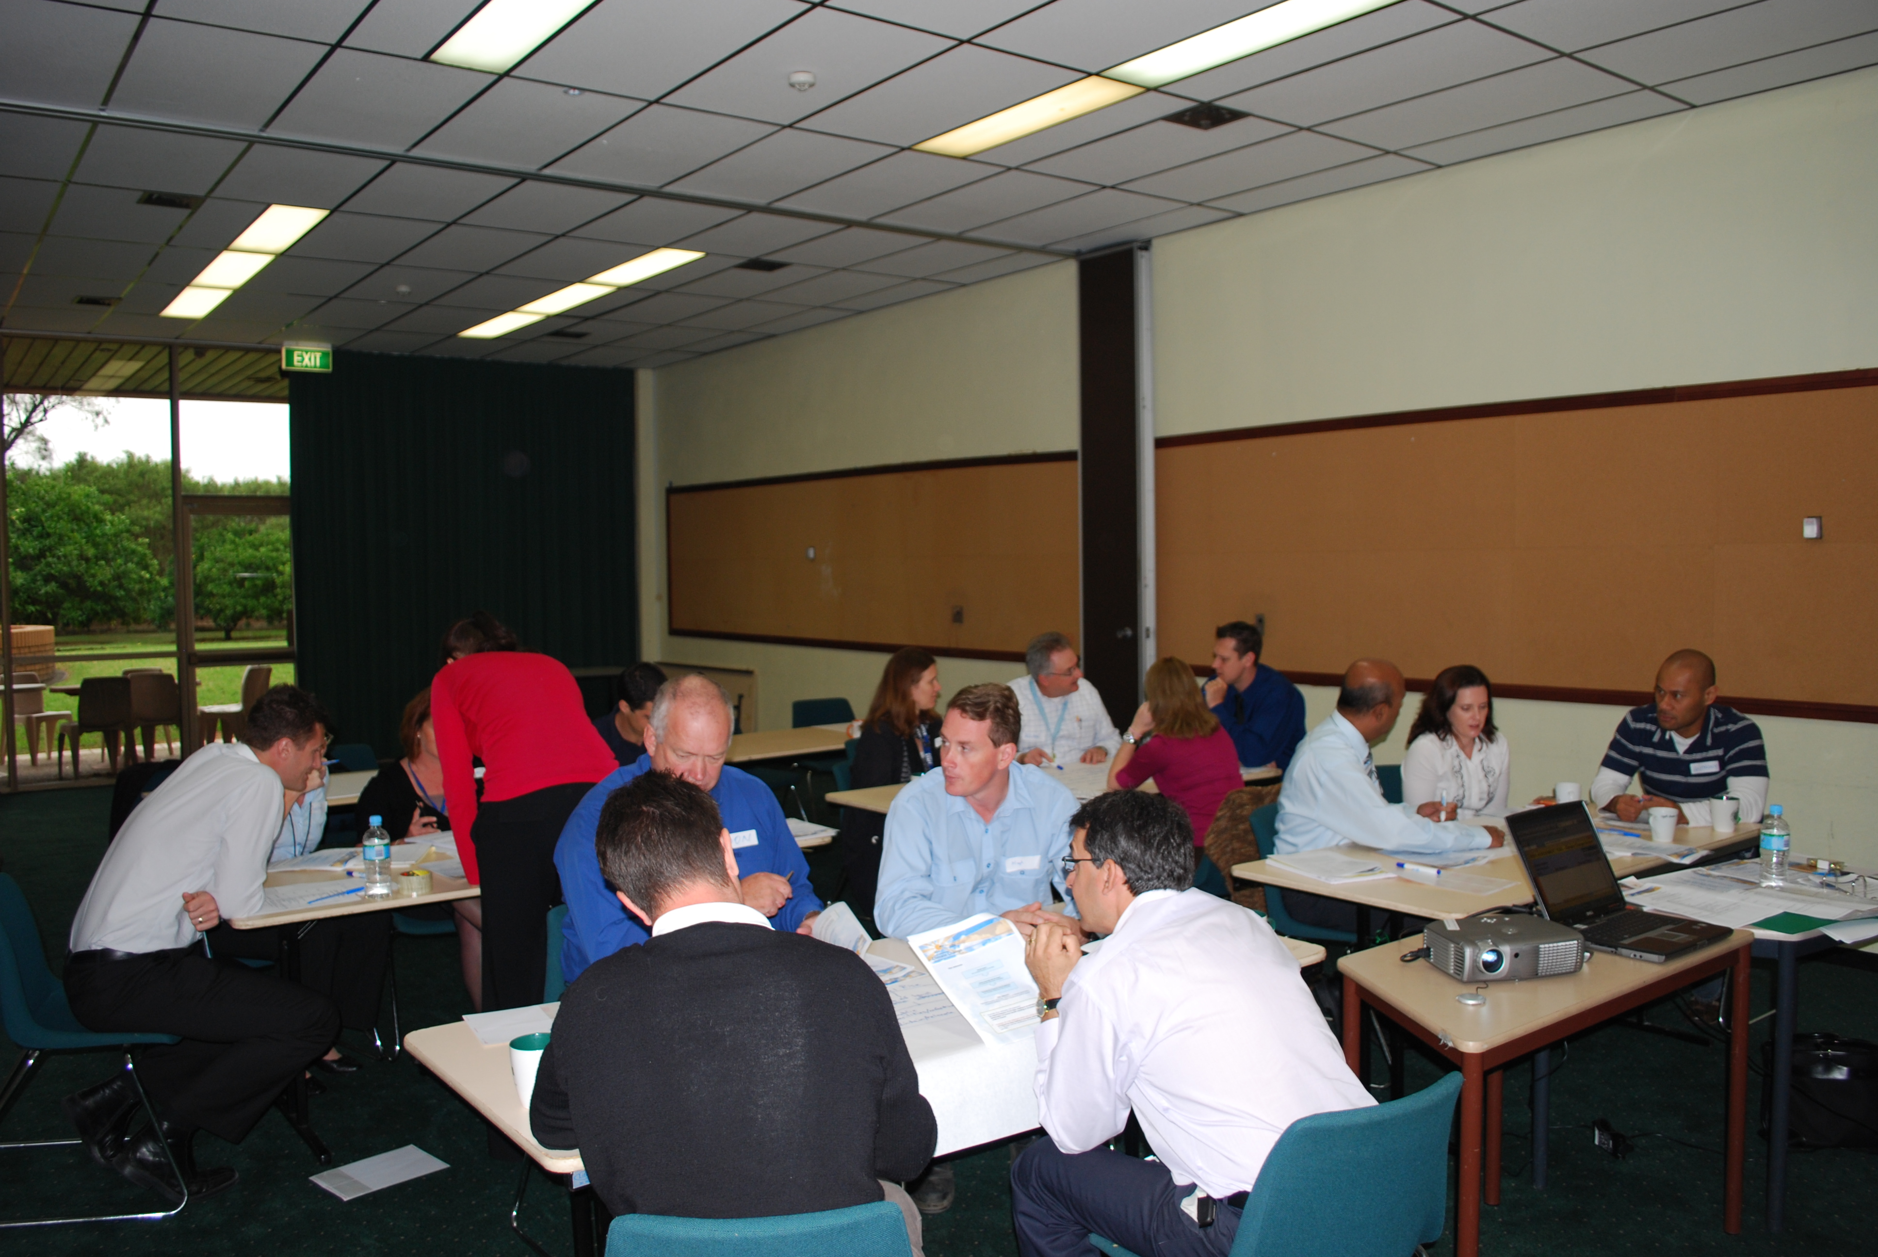
Above: Workshop participants at The Hills Shire Council’s first risk assessment workshop (April, 2010)
- The delivery checklist
After completion of this module you should have achieved the following:
Task | Complete
Presented an appropriate risk assessment framework and its application to climate change impacts | Yes / No
Developed a list of detailed climate change impact risk statements relevant to Council service areas | Yes / No
Facilitated the analysis of each risk statement to determine initial risk levels | Yes / No
Undertaken an evaluation of risks to finalise a list of priority risks to be addressed in an action plan | Yes / No
Administered and collected evaluation survey | Yes / No
Finalised module outputs (as listed on page 10) | Yes / No

- Useful references
AGO, 2006, Climate Change Impacts and Risk Management – A Guide for Business and Government.
AS/NZS ISO 31000:2009, Risk Management – Principles and guidelines.
Ministry of the Environment (NZ Government), 2008, Climate Change Effects and Impacts Assessment: A Guidance Manual for Local Government in New Zealand.

Links to useful resources are provided on the LGSA website (www.lgsa.org.au)

Table 1: Example consequence scales and success criteria for a local Council (AGO, 2006)
Rating | Success Criteria
 |  | Public Safety | Local economy and growth | Community and lifestyle | Environment and sustainability | Public administration | Other success criteria
 | Catastrophic | Large number of injury or loss of life | Regional decline leading to widespread business failure, loss of employment and hardship | The region would be seen as very unattractive, moribund and unable to support its community | Major widespread loss of environmental amenity and progressive irrecoverable environmental damage | Public administration would fall into decay and cease to be effective | A level that would constitute a complete failure
 | Major | Isolated instances of serious injury or loss of life | Regional stagnation such that businesses are unable to thrive and employment does not keep pace with population growth | Severe and widespread decline in services and quality of life within the community | Severe loss of environmental amenity and a danger of continuing environmental damage | Public administration would struggle to remain effective and would be seen to be in danger of failing completely | A level that would constitute a major problem close to complete failure
 | Moderate | Small number of injury | Significant general reduction in economic performance relative to current forecasts | General appreciable decline in services | Isolated but significant instances of environmental damage that might be reversed with intensive efforts | Public administration would be under pressure on several fronts | A significant issue which may be reversed with major efforts
 | Minor | Serious near misses or minor injuries | Individually significant but isolated areas of reduction in economic performance relative to current forecasts | Isolated but noticeable examples of decline in services | Minor instances of environmental damage that could be reversed | Isolated instances of public administration being under severe pressure | No significant harm, but should be considered to prevent further escalation
 | Insignificant | Appearance of a threat but no actual harm | Minor shortfall relative to current forecasts | There would be minor areas in which the region was unable to maintain its current services | No environmental damage | There would be minor instances of public administration being under more than usual stress but it could be managed | A level that would attract no additional attention or resources

Table 2: Example likelihood ratings (AGO, 2006)
Likelihood rating | Recurrent Risks | Single Events
Almost Certain | Could occur several times per year | More likely than not – probability of occurring greater than 50%
Likely | May arise about once per year | As likely as not – 50/50 chance
Possible | May arise once in 10 years | Less likely than not but still appreciable – Probability less than 50% but still quite high
Unlikely | May arise once in 10 years to 25 years | Unlikely but not negligible – Probability low but noticeably greater than zero
Rare | Unlikely during the next 25 years | Negligible – probability very small, close to zero

Table 3: Matrix of likelihood and consequence for prioritisation of risks (AGO, 2006)
Likelihood | Consequence
 |  | Insignificant | Minor | Moderate | Major | Catastrophic
 | Almost Certain | Medium | Medium | High | Extreme | Extreme
 | Likely | Low | Medium | High | High | Extreme
 | Possible | Low | Medium | Medium | High | High
 | Unlikely | Low | Low | Medium | Medium | Medium
 | Rare | Low | Low | Low | Low | Medium

Table 4: Examples of risk controls (AGO, 2006)
Only measures that are already in place or committed and require no further action to be implemented can be claimed as controls. Measures that might be taken to treat risks in the future cannot be assumed to be in place
Controls on degradation of infrastructure:
- Routine monitoring and repair systems
- Inherent robustness in the design and construction
- The existence of alternatives that can be used if the main infrastructure system fails
Controls on flooding due to storms and high tides:
- The existing elevation of homes and other buildings above sea level
- The design and construction of assets that may be affected by flooding
- Existing barrages, levees and other flood control mechanisms
Controls on outbreaks of plant, animal and human diseases:
- Early warning monitoring systems
- Prophylactic treatments already in place
- Naturally occurring mechanisms that compete with or counter the disease and will develop at the same time as the conditions that promote the disease
Controls on movements of population:
- Economic barriers to relocation
- Existing distribution of health, transport and other infrastructure
- Established government programs that provide incentives to remain in place
- Growth of business opportunities associated with climate change that offer fresh employment in existing centres of population

